## **Literature Review / Desk Study**

Knowing the water table is one of the most important aspects of construction that ensures a structure's stability and lifespan. This natural occurrence has a big influence on how roads, buildings, foundations, and other infrastructure are designed and built. The groundwater level, commonly referred to as the water table, is the depth below the surface of the earth at which the soil is fully saturated with water. It is crucial in identifying the kind of drainage systems, foundation, and general building approach needed for a certain project. The water table in construction, its importance, and its effects on building designs and construction methods will all be covered in this article.

## **What is the Water Table in Construction?**

The line separating water-saturated soil from unsaturated soil or air-filled areas above it is known as the water table. Seasons, precipitation, and environmental conditions can all affect its amount. Generally speaking, the water table is at or below the ground's surface, though its depth varies depending on the region.

**High water table:**

A water table is the depth at which groundwater saturates the soil and rock layers beneath the Earth's surface. In instances where this is too close to, or above ground level, it's known as a high water table.

Construction projects require an understanding of the water table, particularly for drainage, soil stability, and foundations. A high water table can cause instability in the soil beneath a building, which can result in problems like settling, flooding, or foundation damage. On the other hand, the soil may be more stable when the water table is low, although drainage and water management still need careful attention.

## **Why is the Water Table Important in Construction?**

### **2.1 High Water Table Issues in Foundation Engineering**

The presence of a high groundwater table significantly complicates foundation design and construction, particularly in coastal or low-lying regions like Mauritius. Water-saturated soils exhibit reduced shear strength due to lower effective stress, governed by the equation

σ′ = σ − u,

(Effective Stress = Total Stress - Pore Water Pressure)

where increasing pore water pressure (u) diminishes the soil’s ability to resist structural loads. This reduction in shear strength directly affects bearing capacity, increasing the risk of foundation failure if not properly accounted for in design (Briaud, 2021).

Settlement concerns are also pronounced. In saturated clayey soils, applied loads expel pore water over time—a process known as primary consolidation. Unlike granular soils, clays exhibit low permeability, leading to long-term, differential settlement. This prolonged movement can manifest as structural cracks, foundation tilting, or misalignment in superstructures, especially where soil properties vary across the site (McGraw-Hill Education, 2010).

Hydrostatic uplift presents another challenge. When upward water pressure surpasses the structural dead load, foundations—especially basements or tanks—can heave or "float." Seasonal groundwater fluctuations or heavy rainfall exacerbate this condition. If structures are not adequately anchored or mass-balanced, uplift can damage substructure elements and compromise waterproofing integrity (Deyell, 2023).

Construction in high water table areas is further hampered by groundwater inflow during excavation. This requires well-planned dewatering strategies, such as well-point systems or sump pumping, which are costly and technically demanding. Additionally, water ingress can cause trench wall instability, reinforcement corrosion, and disruption of concrete pours. Weather conditions and unexpected water level fluctuations add further risk, often leading to project delays and increased cost (Briaud, 2021).

### **2.2 Soil Properties and Their Role in Saturated Conditions**

Understanding soil behavior under saturated conditions is essential. Cohesive soils like marine clays exhibit high plasticity and low permeability, which cause them to retain water and settle slowly. On the other hand, granular soils such as silty sands may drain more quickly but are highly susceptible to liquefaction when saturated. Variations in permeability, compressibility, and grain size distribution across the site influence decisions related to foundation type, drainage requirements, and risk mitigation (McGraw-Hill Education, 2010).

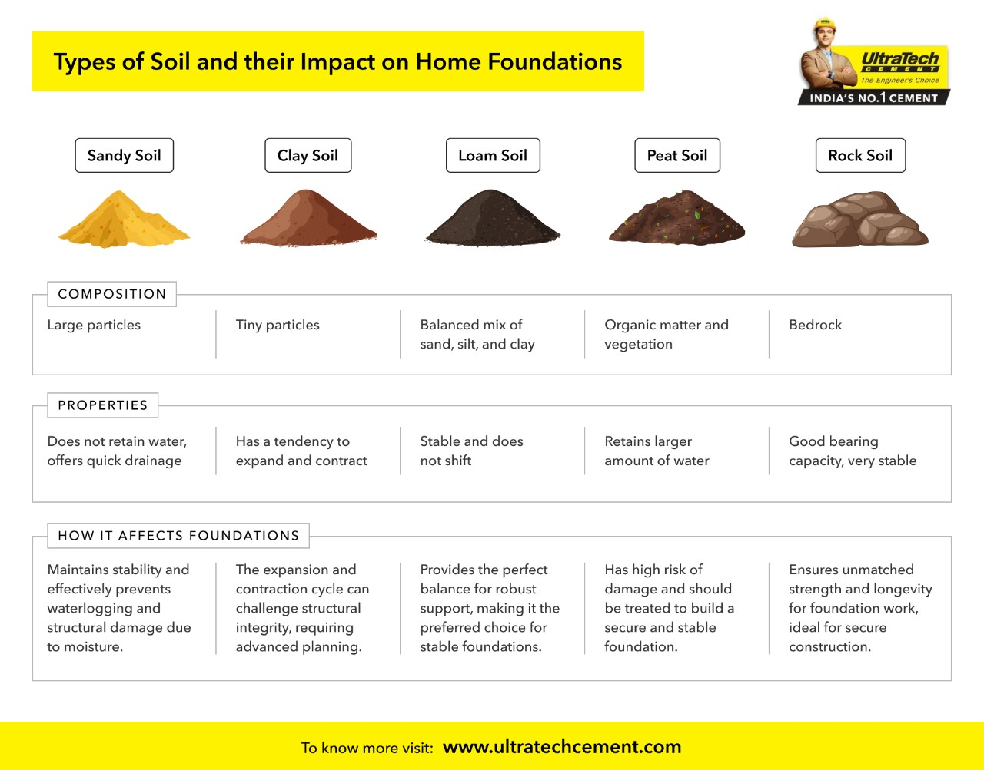

*Image:* [*https://www.ultratechcement.com/for-homebuilders/home-building-explained-single/descriptive-articles/types-of-soil*](https://www.ultratechcement.com/for-homebuilders/home-building-explained-single/descriptive-articles/types-of-soil)

Perched aquifers, weathered zones, and stratified clay lenses further complicate subsurface conditions. These geological discontinuities can create preferential seepage paths or localized saturation zones, resulting in unpredictable settlement and bearing behavior. A thorough geotechnical investigation—including boreholes, permeability tests, and piezometer installation—is crucial for characterizing the subsurface in high groundwater areas (Briaud, 2021).

### **2.3 Foundation Materials and Structural Response**

The choice of foundation materials plays a critical role in saturated conditions. Reinforced concrete is generally preferred due to its durability and resistance to water ingress, but only if properly designed and cured. Waterproof concrete mixes, integral admixtures, and corrosion-resistant reinforcement (e.g., epoxy-coated bars) enhance performance in wet environments (Deyell, 2023).

Masonry and untreated steel foundations, on the other hand, are more vulnerable. Masonry units can absorb water and degrade over time, while unprotected steel corrodes in high-moisture environments. In coastal zones, salinity compounds these risks, making material durability and protective coatings essential considerations.

In some cases, ground improvement techniques—such as grouting, soil stabilization with cement, or vibro-compaction—are applied prior to foundation placement to enhance bearing capacity and reduce permeability. These techniques allow the use of shallow foundations in otherwise unsuitable saturated soils (Briaud, 2021).

### **2.4 Waterproofing in Saturated Soil Conditions**

Waterproofing is indispensable when constructing below or near the groundwater table. For basement structures, retaining walls, or foundation slabs, designers often adopt a combination of external membranes (e.g., bituminous or PVC sheets) and internal protection like crystalline coatings. These systems help prevent water ingress through joints, microcracks, or porous zones in concrete (Deyell, 2023).

Crystalline waterproofing, in particular, reacts with free water to form insoluble crystals that block capillary pores. Integral waterproofing admixtures can also be added directly into concrete to reduce permeability. Joint sealing using hydrophilic waterstops and proper detailing around pipes and service entries are critical to ensure the continuity of the waterproofing barrier (Briaud, 2021).  
Effective foundation waterproofing is crucial in construction to prevent water infiltration, which can compromise structural integrity and indoor air quality. Various systems are employed to ensure foundations remain dry and durable.[UltraTech Cement+2AlSyed Construction+2AlSyed Construction+2](https://alsyedconstruction.com/understanding-waterproofing-in-construction/?utm_source=chatgpt.com)

### **2.4.1 Types of Foundation Waterproofing Systems:**

#### **1. Fluid-Applied Membranes**

Fluid-applied membranes are monolithic coatings applied directly to foundation surfaces. They can be categorized into cold and hot fluid-applied systems.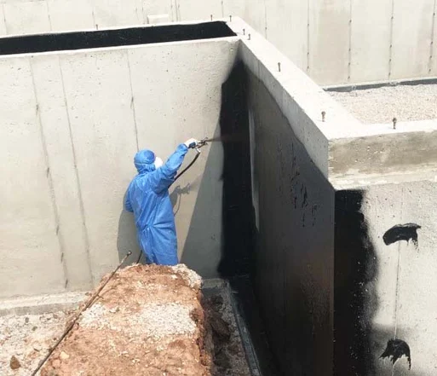

*Image: Fluid-applied membrane application process.* [*https://www.tremcosealants.com/blog/tips-for-residential-and-multi-family-fluid-applied-waterproofing*](https://www.tremcosealants.com/blog/tips-for-residential-and-multi-family-fluid-applied-waterproofing)

* **Cold Fluid-Applied Membranes**: These are typically polyurethane, polymer-modified asphalt, or synthetic rubber-based. They are applied at ambient temperatures and cure to form a seamless barrier. However, care must be taken during application to prevent issues like pinholing due to vapor release.
* **Hot Fluid-Applied Membranes**: These involve heating rubberized asphalt to high temperatures before application. They are often reinforced with fabrics to enhance durability. Hot-applied systems are more labor-intensive and require cured substrates.[AlSyed Construction](https://alsyedconstruction.com/foundation-moisture-problems-in-construction-in-the-usa-how-to-prevent-and-address-them/?utm_source=chatgpt.com)

#### **2. Self-Adhered Membranes**

Self-adhered membranes are sheet materials with adhesive backings that bond to the substrate. Common types include:

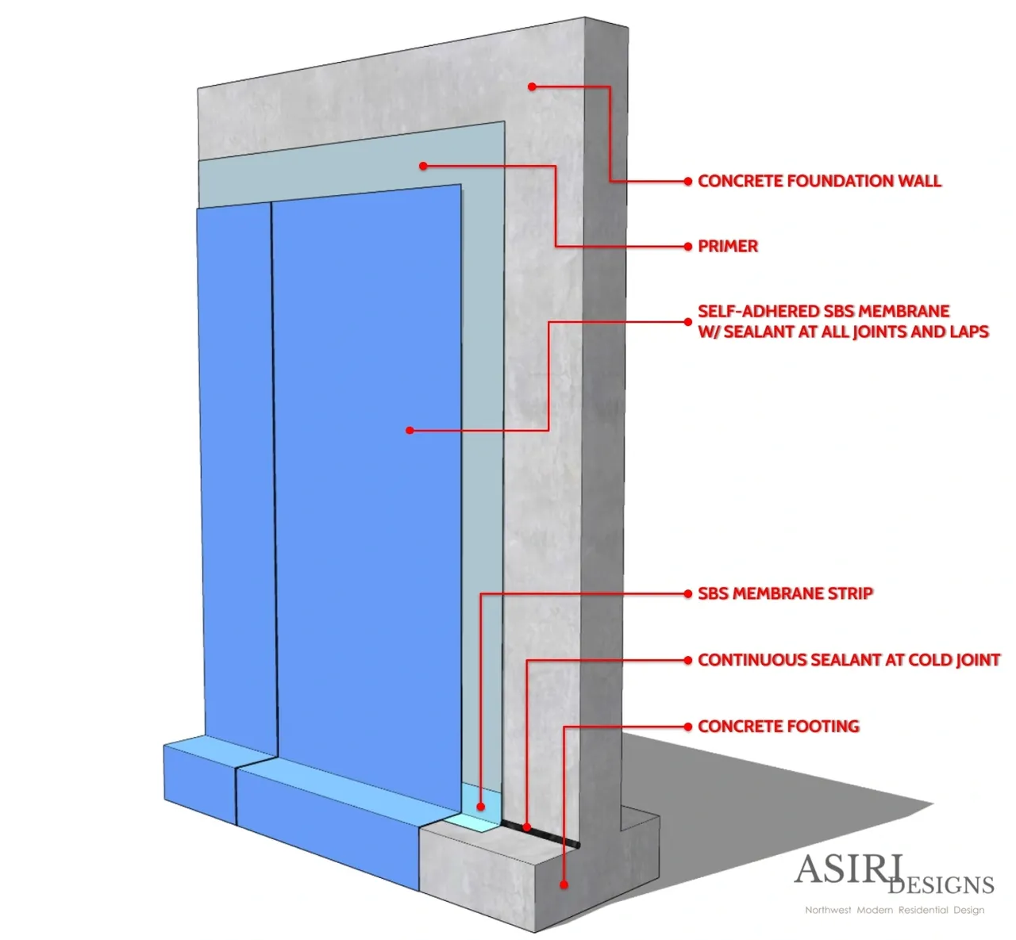

*Image: Installation of self-adhered membrane on foundation wall.* [*https://asiri-designs.com/resources-1/f/types-of-foundation-waterproofing-systems?blogcategory=Basements*](https://asiri-designs.com/resources-1/f/types-of-foundation-waterproofing-systems?blogcategory=Basements)

* **SBS Rubberized Asphalt Membranes**: Widely used for below-grade applications, these membranes require clean, primed surfaces for optimal adhesion.
* **EPDM Membranes**: Known for their flexibility and resistance to UV and ozone, EPDM membranes are suitable for various applications but may be sensitive to certain chemicals.
* **TPO Membranes**: Thermoplastic polyolefin membranes are heat-welded at seams, providing strong, watertight joints. They are resistant to a range of chemicals but require protection from prolonged UV exposure.

#### **3. Pressure-Sensitive Adhesive Membranes**

These membranes are designed for pre-applied or "blindside" applications, where the membrane is placed before the concrete pour. The pressure from the concrete activates the adhesive, forming a strong bond. They are ideal for sites with high water tables or limited access.

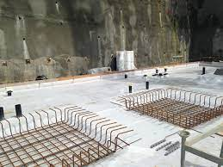

*Image: Pressure-sensitive adhesive membrane setup before concrete pour.*

#### **4. Bentonite Systems**

Bentonite waterproofing utilizes the natural swelling properties of bentonite clay to seal against water ingress. When hydrated, bentonite expands to fill voids and cracks, forming an impermeable barrier. These systems are often used in blindside applications and require confinement to function effectively.  
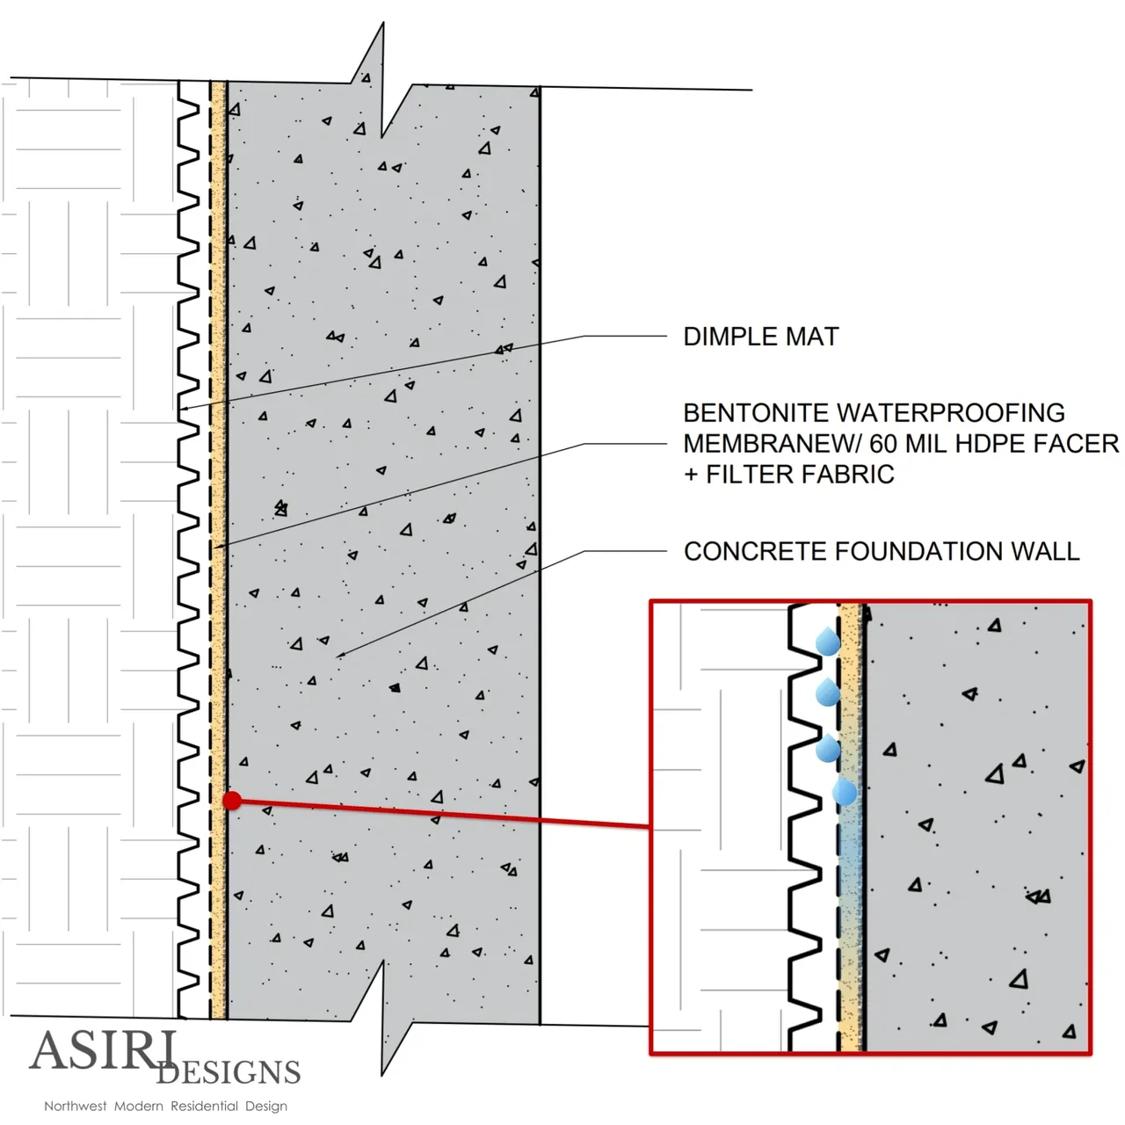

*Image: Cross-section of bentonite waterproofing system.* [*https://asiri-designs.com/resources-1/f/types-of-foundation-waterproofing-systems?blogcategory=Basements*](https://asiri-designs.com/resources-1/f/types-of-foundation-waterproofing-systems?blogcategory=Basements)

#### **5. Cementitious Slurries**

Cementitious waterproofing involves applying a mixture of cement and waterproofing agents to concrete surfaces. It's commonly used for internal waterproofing of water-retaining structures like water tanks and basements. While easy to apply, these systems may not accommodate significant structural movement.[Waterproof+2AlSyed Construction+2AlSyed Construction+2](https://alsyedconstruction.com/understanding-waterproofing-in-construction/?utm_source=chatgpt.com)

*Image: Application of cementitious slurry on concrete wall.*

### **Importance of Waterproofing in High Water Table Areas**

In regions with high water tables, such as coastal areas or locations with poor drainage, effective waterproofing is paramount. A high water table can exert hydrostatic pressure on foundations, leading to water infiltration and structural damage. Implementing robust waterproofing systems, along with proper drainage solutions, ensures the longevity and safety of structures in such challenging environments.  
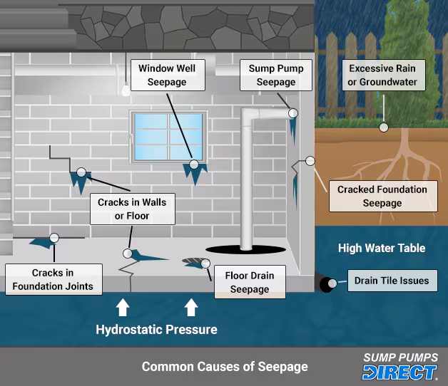

*Image: Diagram illustrating hydrostatic pressure on foundation walls* [*https://www.sumppumpsdirect.com/stories/1725-How-to-Waterproof-Your-Basement.html*](https://www.sumppumpsdirect.com/stories/1725-How-to-Waterproof-Your-Basement.html)*.*

### **2.5 Seepage and Drainage Control Measures**

To control lateral and vertical seepage, engineers commonly install cutoff walls, sheet piles, or secant pile walls. These vertical barriers help prevent groundwater migration into the construction zone. Below-ground drainage systems—such as French drains or gravel-packed trenches—collect and redirect water to sumps or pumps (McGraw-Hill Education, 2010).

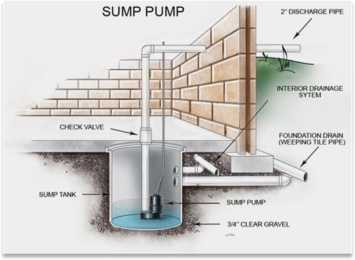

*Image:* [*https://www.millers-va.com/sump-pump/*](https://www.millers-va.com/sump-pump/)

In permanent installations, subsoil drainage helps maintain long-term stability and reduces hydrostatic buildup under slabs. Relief wells or under-drains may be used to relieve uplift pressures beneath structures such as tanks or reservoirs. Proper slope grading and surface water diversion further ensure that rainfall or stormwater does not exacerbate groundwater levels near foundations (Deyell, 2023).

### **2.6 Shallow vs. Deep Foundations in High Groundwater Areas**

Shallow foundations, like strip or raft footings, are typically cost-effective and easy to construct. However, in high water table conditions, their performance is compromised unless significant waterproofing and subsoil drainage measures are adopted. Water ingress during excavation is common, and the surrounding saturated soil may offer insufficient bearing support (McGraw-Hill Education, 2010).

Deep foundations—such as bored piles or driven precast piles—are generally more suitable. They transfer loads to deeper, denser strata or bedrock layers unaffected by surface water fluctuations. In addition to greater load-bearing capacity, piles resist hydrostatic uplift when adequately socketed or anchored. Nevertheless, these systems require specialized equipment and careful monitoring to ensure alignment, verticality, and structural integrity (Briaud, 2021).

### **2.7 Slurry Wall Construction for High Groundwater Table Conditions**

Slurry wall construction is a well-established geotechnical technique used predominantly in locations where high groundwater levels pose challenges to deep excavations and foundation systems. It is especially suitable for structures situated near rivers, oceans, or other bodies of water, and is frequently implemented in the construction of tunnels, flyover piers, metro systems, and deep building foundations.

The core function of a slurry wall is to serve as a groundwater cut-off barrier while also providing lateral earth support. A trench is first excavated in the ground, supported temporarily by a slurry mixture—commonly bentonite and water—to prevent collapse of the trench walls. Once excavation reaches the desired depth, steel reinforcement cages are installed into the slurry-filled trench. The final stage involves tremie placement of concrete, which displaces the slurry upward while forming the permanent wall.  
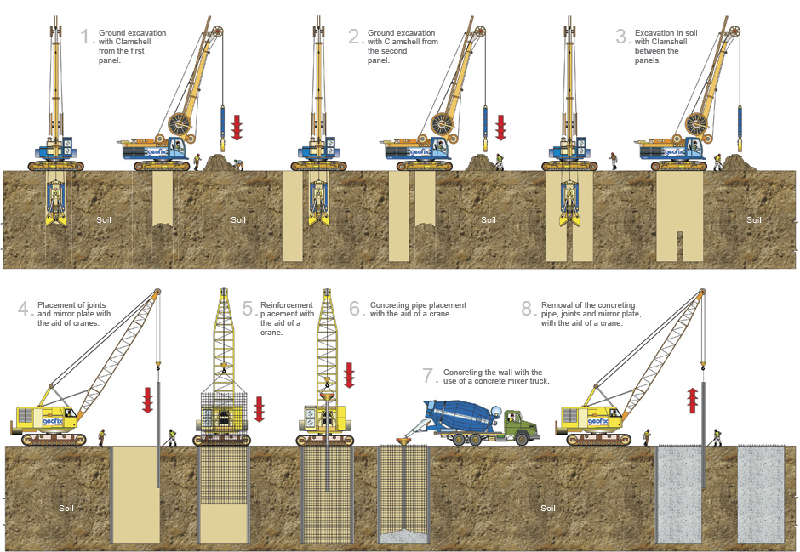  
*Image:* [*https://www.geofix.com.br/en/servico-paredes-hidrofresa.php*](https://www.geofix.com.br/en/servico-paredes-hidrofresa.php)

#### **Purpose and Applications**

Slurry walls serve multiple purposes in foundation engineering:

* Provide structural stability and long-term support for heavy infrastructures.
* Act as barriers to groundwater intrusion or lateral water flow.
* Enhance tunnel, metro, and bridge foundation grip in soft or saturated soils.
* Serve as integral components in dam construction and environmental containment systems.

Their application is particularly critical for ensuring the safety and performance of deep excavations in urban or hydrologically sensitive zones.

#### **Construction Process Overview**

The standard procedure for slurry wall construction involves:

1. **Excavation** – Deep trenches are excavated using heavy machinery, often with continuous monitoring of groundwater and soil conditions.
2. **Slurry Filling** – A bentonite-water slurry is introduced into the trench to prevent sidewall collapse and minimize soil displacement.
3. **Placement of Reinforcement** – Steel cages are lowered into the slurry-filled trench, which will later bond with the concrete to form a reinforced wall.
4. **Concreting** – Concrete is poured through tremie pipes, displacing the slurry and forming the final wall structure.

This sequence must be meticulously executed to prevent issues like trench collapse, slurry contamination, or insufficient bonding between the concrete and reinforcement.

#### **Advantages**

Slurry wall systems offer several engineering and economic advantages:

* **Cost-effective** compared to alternative dewatering or cofferdam solutions.
* **High strength and durability**, suitable for long-term and high-load applications.
* **Minimal material waste** due to the potential reuse of excavated soil.
* **Adaptability to complex urban environments**, particularly in projects requiring minimal ground movement or vibration.

#### **Limitations and Challenges**

Despite their benefits, slurry wall construction has limitations:

* Requires **skilled labor and technical supervision**, especially for slurry management and concrete placement.
* **Heavy machinery** and **large work areas** are essential, which may be impractical in dense urban locations.
* **Precise slurry-concrete separation** is critical to avoid contamination and structural weakness.
* Potential **material quality issues** can affect performance if not carefully controlled.

#### **Relevance to Foundation Design in High Water Table Areas**

In the context of designing foundations where the water table is high, slurry walls play a crucial role in enabling safe, dry, and stable excavation. Their impermeability and structural capacity make them a preferred solution where conventional shallow foundations or open excavations are not viable. Moreover, they align with sustainable construction practices due to their longevity, reusability of materials, and reduction in groundwater-related hazards.

### **2.8 Environmental Considerations in Dewatering and Groundwater Control**

Dewatering and drainage operations must be carefully managed to minimize environmental harm. Aggressive dewatering can draw down the water table beyond the construction zone, potentially affecting nearby vegetation, foundations, or boreholes. It may also lead to soil desiccation and settlement in surrounding areas (Deyell, 2023).

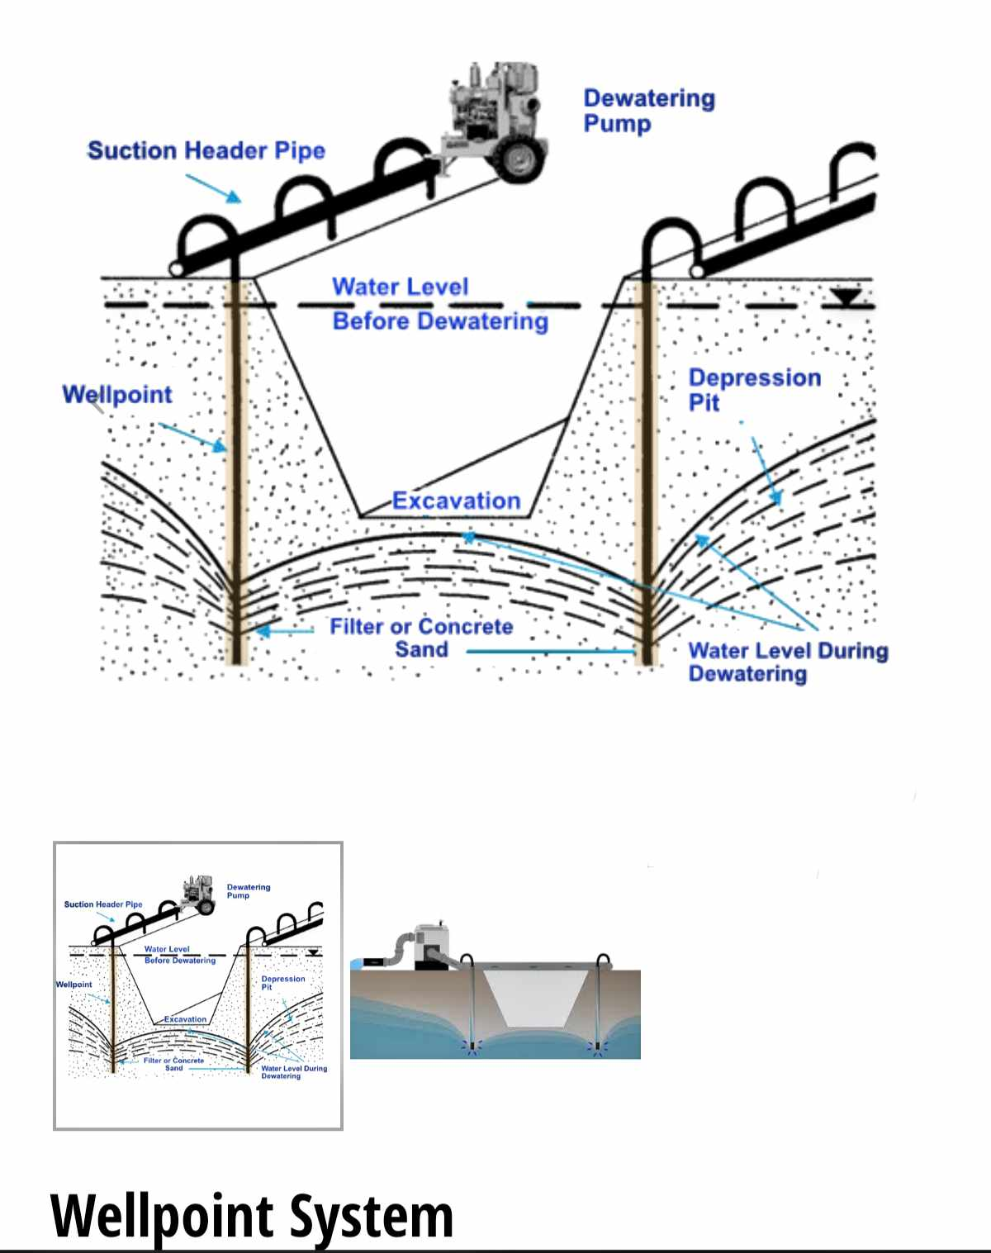

*Image:* <https://sunshinecoastdewatering.com.au/installation/>

In coastal environments or near wetlands, the removal of groundwater may disrupt local hydrology or salinity balances. Additionally, pumped water may carry suspended solids, oil, or contaminants, which necessitates treatment before discharge. Regulatory bodies may impose strict controls on dewatering volumes, discharge locations, and water quality standards. Therefore, environmental impact assessments and mitigation plans should form part of the early design process (Briaud, 2021).

### 

### 

### **References**

* Briaud, J.-L. (2021). *Geotechnical Engineering: Unsaturated and Saturated Soils*. John Wiley & Sons.
* Deyell, D. (2023). *Understanding Hydrostatic Pressure*. *Waterproof! Magazine*. [online] Available at:<https://www.waterproofmag.com> [Accessed 4 May 2025].
* McGraw-Hill Education. (2010). *Shallow and Deep Foundations: Design and Construction*. New York: McGraw-Hill Professional.

<https://asiri-designs.com/resources-1/f/types-of-foundation-waterproofing-systems?blogcategory=Basements>

<https://alsyedconstruction.com/understanding-the-water-table-in-construction-a-complete-guide/>